**EV Market Segmentation Summary Report**

The electric vehicle (EV) sector in India is expanding rapidly, supported by environmental concerns, proactive government policies, and a worldwide transition toward sustainable mobility. With rising urban pollution, increasing fuel costs, and the need to cut carbon emissions, EVs are becoming a strong alternative to conventional internal combustion engine (ICE) vehicles.

Although India’s EV market is still developing compared to global benchmarks, it has experienced remarkable growth in recent years. According to an *Economic Times* survey, the domestic EV industry is projected to grow at a compound annual growth rate (CAGR) of 49% between 2022 and 2030, reaching one crore annual sales by 2030. This surge is attributed to favorable government policies, technological progress, and growing consumer awareness of the long-term advantages of EVs.

The Indian government has rolled out initiatives like the Faster Adoption and Manufacturing of Electric Vehicles (FAME) scheme, aimed at encouraging EV adoption. State governments have also introduced measures such as subsidies, tax exemptions, and incentives for charging infrastructure development, further accelerating adoption.

India’s EV market is segmented by vehicle type—2-wheelers, 3-wheelers, and 4-wheelers—each catering to specific consumer demands and usage scenarios. Additionally, geographic factors significantly impact adoption, with certain states and union territories leading due to better infrastructure, supportive policies, and higher consumer acceptance.

**Process Overview**

**Libraries and Frameworks Used:**

* NumPy: Fast numerical calculations and array processing.
* Pandas: Data loading, cleaning, and summary statistics.
* Matplotlib.pyplot: Basic graphs and trend lines.
* Seaborn: Advanced statistical visualizations.
* sklearn: Machine learning algorithms

1. StandardScaler: Feature normalization
2. Silhouette score: Cluster validation and quality assessment

**Dataset Source:**

* [**/kaggle/input/electric-vehicle-2023/smev_data.xlsx**](/kaggle/input/electric-vehicle-2023/smev_data.xlsx%22)
* [**https://www.kaggle.com/datasets/karivedha/indian-consumers-cars-purchasing-behaviour/data**](https://www.kaggle.com/datasets/karivedha/indian-consumers-cars-purchasing-behaviour/data)

The datasets used in the EV market segmentation analysis contain the following key features:

**EV Sales Data Features**

* YEAR: Date mark indicating sales month/year (e.g., 2017-04-01)
* 2 W: Sales volume of 2-wheeler electric vehicles
* 3 W: Sales volume of 3-wheeler electric vehicles
* 4 W: Sales volume of 4-wheeler electric vehicles
* BUS: Sales volume of electric buses
* TOTAL: Total EV sales across all vehicle types for that period

**Customer Profile Data Features**

* Age: Customer age in years (ranging approx. 26 to 51 years)
* Profession: Categorical variable indicating salaried or business
* Marital Status: Single or married status
* Education: Level of education (e.g., Graduate, Post Graduate)
* No of Dependents: Number of dependents in family
* Personal Loan: Whether the customer has a personal loan (Yes/No)
* Total Salary: Annual income in INR (approx. 200,000 to 5,200,000)
* Price: Price of the vehicle purchased (approx. 110,000 to 3,000,000 INR)

The workflow framework used in your EV market segmentation analysis typically follows these key stages:

1. **Data Collection and Loading**
   * Gather datasets on EV sales by vehicle type over time and customer demographic/financial profiles.
   * Load the data into Python using pandas from Excel or CSV files.
2. **Data Cleaning and Preprocessing**
   * Handle missing values and verify data integrity.
   * Convert date columns to appropriate datetime types.
   * Normalize numerical features like Age, Salary, and Price using StandardScaler from sklearn to ensure consistent scales.
3. **Exploratory Data Analysis (EDA)**
   * Use pandas to compute descriptive statistics and distributions.
   * Apply visualization libraries matplotlib.pyplot and seaborn to plot sales trends over time and customer segment characteristics.
4. **Feature Engineering and Selection**
   * Select relevant features for segmentation such as Age, Salary, Price, Profession, etc.
   * Perform dimensionality reduction using PCA (Principal Component Analysis) to reduce complexity while retaining variance.
5. **Customer Segmentation Modeling**
   * Employ clustering algorithms like K-Means from the sklearn library.
   * Use clustering evaluation metrics such as silhouette score to choose an optimal number of clusters.
6. **Interpretation and Visualization of Clusters**
   * Visualize segmented clusters in 2D/3D PCA space for better understanding.
   * Analyze cluster characteristics to tailor marketing and product strategies.
7. **Reporting and Strategic Recommendations**
   * Summarize insights from sales trends and customer segments.
   * Recommend focusing on promising vehicle types (such as 2-wheelers) and aligned customer segments for effective market capture.

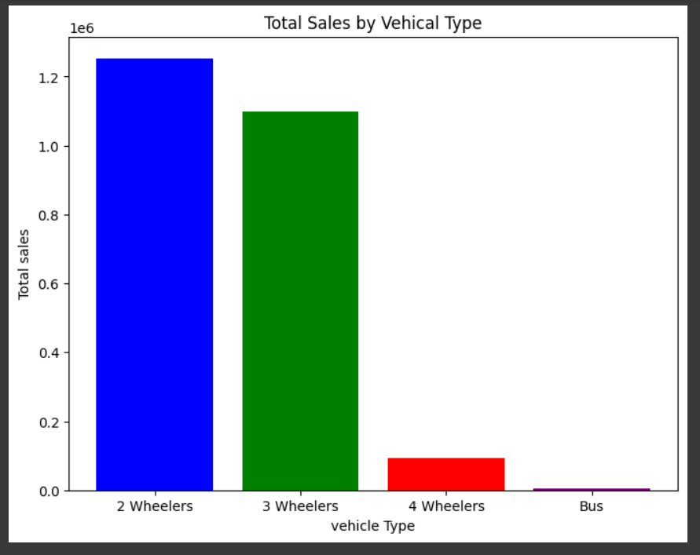

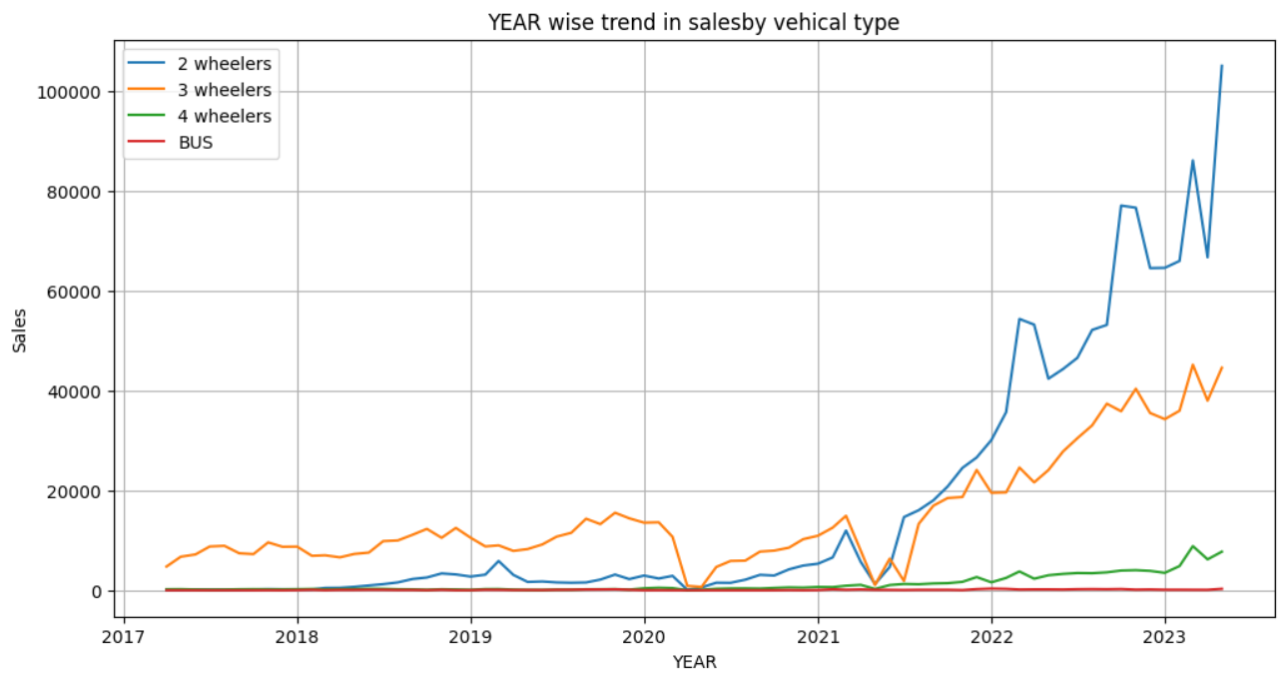

**Sales Trend Analysis (2017–2023)**

By concentrating on the **2W segment**, the company is best positioned to capitalize on the most dynamic and expansive segment of India’s rapidly evolving EV market.

**Graph Explanation**

* The primary graph visualizes **sales trends over time (2017-2023) for each vehicle segment**. It shows that:
  + Sales for 2W EVs rapidly increased, especially post-2021.
  + 2Ws regularly contributed the largest share of total EV sales.
  + Other segments (3W, 4W, BUS) showed growth but at a much lower magnitude.
* **Annual comparison** confirms that 2W sales consistently outperform other segments, as seen in tabulated values (e.g., 2022: 630,725 units for 2W versus 350,129 for 3W and much lower for 4W and BUS).

The Indian electric vehicle (EV) market has undergone a transformative shift in the last several years, with **2-wheeler (2W) EVs** emerging as the undisputed leader in sales and growth trajectory.

**Customer Segmentation Analysis**

**Profile Summary**

|  |  |  |  |  |
| --- | --- | --- | --- | --- |
| **Variable** | **Mean** | **Std Dev** | **Min** | **Max** |
| **Age** | 36.3 | 6.25 | 26 | 51 |
| **Dependents** | 2.18 | 1.33 | 0 | 4 |
| **Salary (₹)** | 2.27 M | 1.05 M | 0.20 M | 5.2 M |
| **Price (₹)** | 1.19 M | 0.44 M | 0.11 M | 3.0 M |

* **Profession:** Majority salaried, followed by business.
* **Education:** Predominantly postgraduates and graduates.
* **Marital Status:** High proportion married, with dependents.
* **Loan:** Personal loans common, indicating price and financing sensitivity.

**Customer Archetype:** Urban, educated, middle-aged professionals with family responsibilities, preferring lower price points and financing.

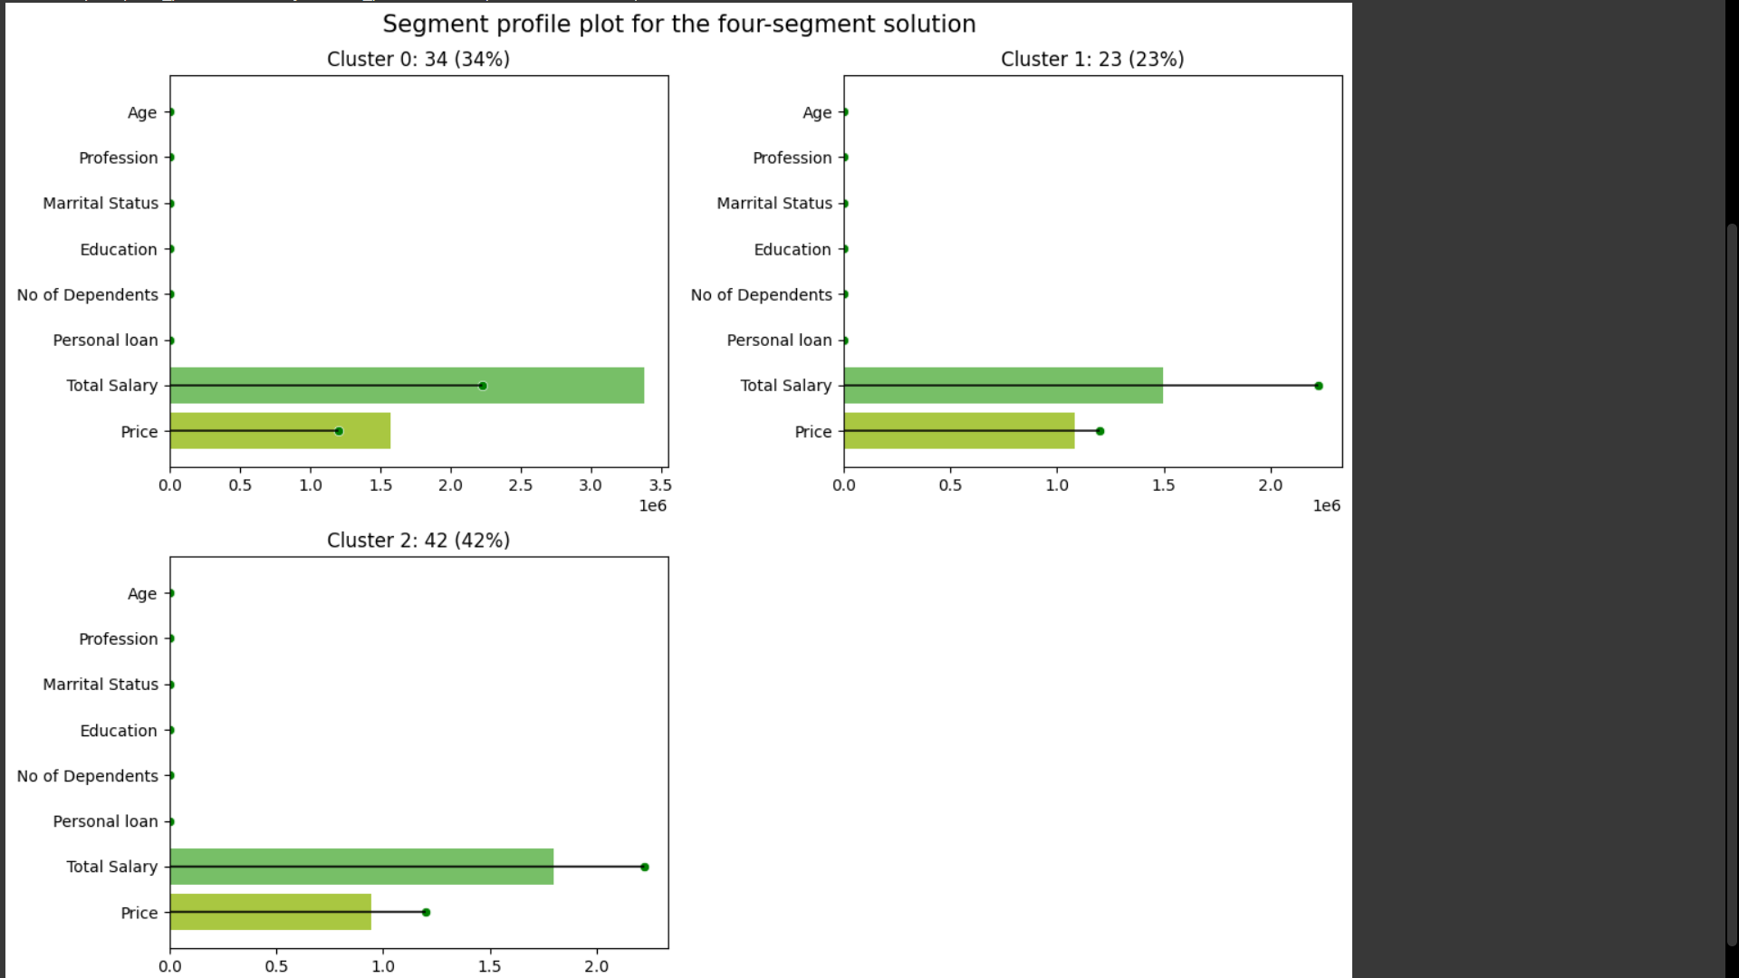

**Business Recommendations:**

* Direct R&D, production, marketing, and distribution investments toward **2W EVs**.
* Leverage financing solutions and targeted digital outreach for working professionals.
* Continued market research on evolving customer preferences (salary, dependents, education, loan needs).
* Develop service/support infrastructure attuned specifically to 2W vehicle maintenance and after-sales.

**Conclusion**

* The analysis of Indian electric vehicle (EV) market sales data reveals a significant growth trend, particularly in the **2-wheeler (2W) segment**, which consistently outperforms other vehicle types such as 3-wheelers (3W), 4-wheelers (4W), and buses in terms of sales volume from 2017 to 2023.
* Based on recent years’ data, **2W electric vehicles are the most promising segment for maximum sales impact and market penetration**. This makes them the ideal focus for companies aiming for rapid growth and wider adoption in the EV sector.

**Conclusion**

Focusing on the **2-wheeler segment** aligns with clear, data-backed trends in India’s EV market. Companies that prioritize 2W models, tailor products to young professionals, and ensure affordable financing and after-sales service are best placed to dominate this sector in the coming years.

**Solution for the Company**

**Strategic Recommendations:**

* **Focus investments and product development on 2W electric vehicles.** These offer:
  + Largest market base and established demand.
  + Faster adoption among younger buyers and urban commuters.
  + Lower entry price and higher mobility for the Indian demographic.
* **Use customer segmentation insights** to tailor marketing and financing:
  + Target segments based on age (mean buyer ~36 years), profession (salaried/business), and loan/price sensitivity.
  + Promote popular price brackets and facilitate personal loan options.
* **Scaling production and distribution** for 2W EVs will likely yield the highest ROI and growth, per the current market data analysis.[1]